SQL Assignment – 9
Querying Multiple Tables at Once.

1) Write a query that lists ea20 ptch order number followed by the name of the customer who made the
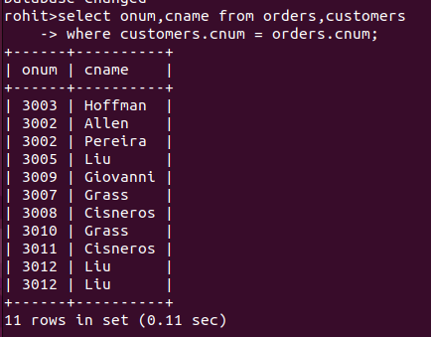
order.

2) Write a query that gives the names of both the salesperson and the customer for each order along
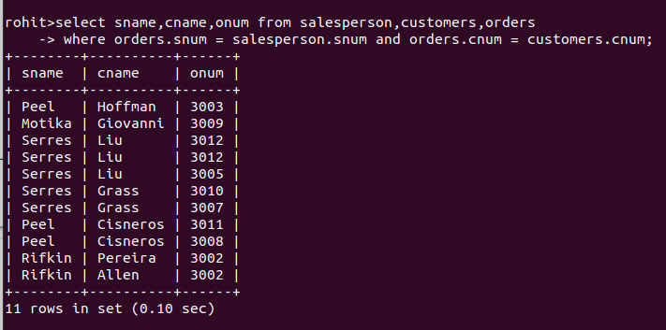
with the order number.
3) Write a query that produces all customers serviced by salespeople with a commission above 12%. Output the customer’s name, the salesperson’s name, and the salesperson’s rate of commission.
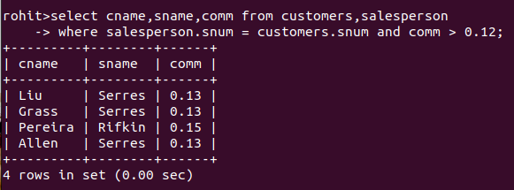

4) Write a query that calculates the amount of the salesperson’s commission on each order by a
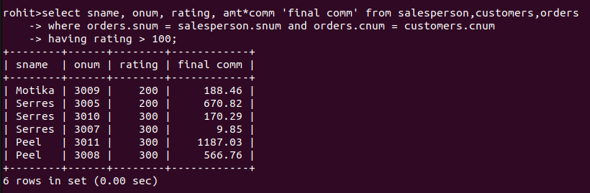
customer with a rating above 100.

